Fixing Chrome to Open pdf's (Learning Guides and Projects)
Step 1: When in Chrome, click menu (3 dots in top right), then click on Settings. 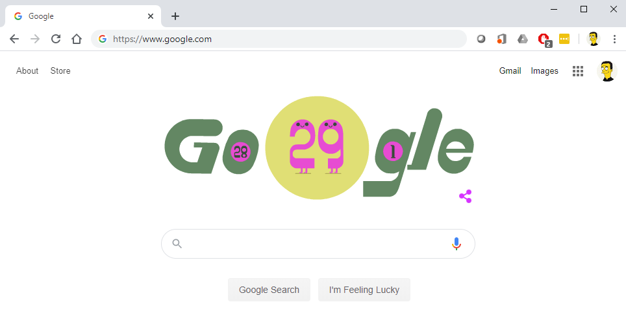
Step 2: From within "You and Google" click on "Sync and Google services."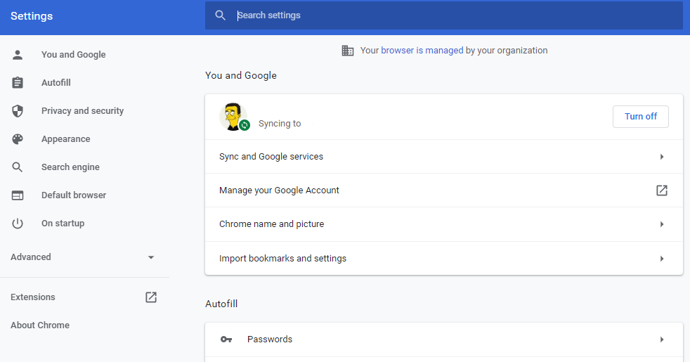
Your name.
Syncing to youremail@gmail.com

Step 3: Scroll down to "Other Google services" and turn OFF "Make searches and browsing better"
